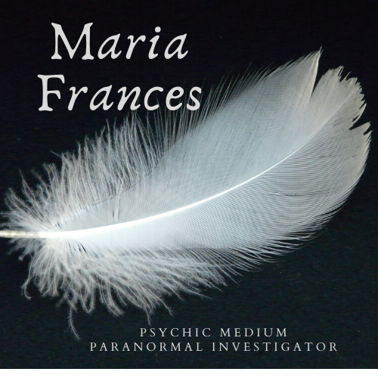

Client Questionnaire
All information contained in this form will be kept strictly confidential.

Date of Initial Contact: / / _ Date of Interview: / /
Initial contact made by: __________________________
□ phone □ e-mail__

********** Location Information **********
(All information on this form will be kept confidential unless permission granted by interviewee(s) to release information publicly.)

Name(s) of Client: Address: City/State/Zip: _ Phone:
E-mail address:

********** Occupant Information **********
Names, gender, and age of occupants (add additional to back of sheet or attach):

1. □ M □ F
2. □ M □ F
3. □ M □ F
4. □ M □ F
5. □ M □ F
6. □ M □ F
7. □ M □ F
8. □ M □ F
9. □ M □ F
10. □ M □ F
Own or Rent?
Willing to sign waiver forms? Y N
Employed?
Single Married Divorced

Age of Home or apartment?____________
Time at residence: Number of bedrooms:

To your knowledge is there a historical significance to the home or land home is on?

Can you provide pictures of all rooms with activity and casual quick pictures of the household members? Y N

Religion: All baptized: Yes No

Belief in a higher power? Y N

Any strains on the relationships with the people living in the home? Arguments, etc?
Has the location ever been blessed?

Has there been any recent remodeling?

Has there been any media involvement?

Are any of the occupants on prescribed medication? (Anxiety, depression, etc.)

Any of the occupants currently seeing a psychiatrist or therapist?

Any occupants with frequent unexplained illness?

Have any of the occupants experienced nightmares or had trouble sleeping?

Do any of the occupants use illegal drugs?

Are there any pets on the property?

Do pets seem to follow something with their eyes or have a fearful reaction without any apparent reason?

Is any resident of the property known to have or believed to have psychic abilities? (empathic, sense things, know things before they happen etc)

Are any of the occupants interested in the occult?

Has anyone gone to a noted haunted location?

Has anyone gone to an abandoned structure and/or taken
anything from that structure?

Has anyone befriended, met with anyone who is into the dark arts, goth movement, violent movements etc?

Has anyone purchased used items whether it furniture or clothing etc?

(Ouija boards, séances, psychics, spells, etc.)?

Has there been a visitor to the home whose presence was awkward, questionable or they were wrought with emotion?

Have there been any other witnesses, besides the occupants?

Any family history of alcohol abuse, domestic issues, prison, etc?

Notes from the above questions:
Please know, the more detailed you can be and honest. The better I can help you. No you are not crazy.

